WORK INTERGRATED LEARNING
MODULE CODE: XISD5319
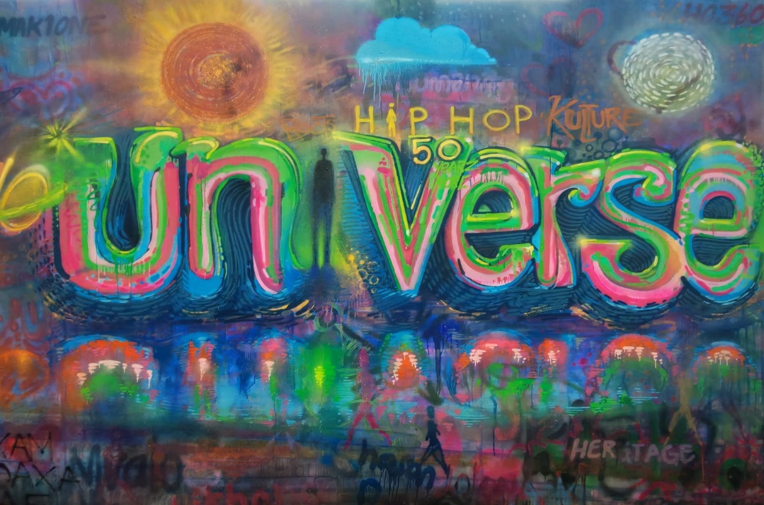
TASK 1

TEAM NAME: Core3 Systems

GROUP MEMBERS
RAFIQAH KIRBY - ST10438554
ARMALENE MAGERMAN - ST10454097
CHLOE LANGENHOVEN - ST10435895


NAME OF CLIENT
Iziko Museums of South Africa
(ART GALLERY)
Chief Educator: Art - Rory Emmett

Table of Contents

Introduction 3
Milestones and Deliverables 4
Project Schedules (Gantt Chart) 5
Work Breakdown Structure 6
Risk Management 7
Technical Feasibility 9
Hardware Resources 9
Software Resources 10
Economic Feasibility 11
Team Members 13
Rafiqah Kirby 13
Armalene Magerman 13
Chloe Langenhoven 13
CV 14
References 17

Introduction
The main idea of this project is to make it easier for people to visit the Iziko Art Gallery using an app. The Iziko Art Museum of South Africa want to use this app to make African art more accessible to people who are not in the actual museum. They want to get youth and tourists from other countries to look at South African art.
At this present moment, people can only view the art at the Iziko Art Gallery if they go there in person. This can be a problem for people who lives abroad. Younger people like to use their phones and computers to learn things and get involved in activities. The new mobile app for the Iziko Art Gallery will let people look at the art and read about it on their phones. They can learn about the culture and history of each piece of art at the comfort of their fingertips. This will help the Iziko Museum of South Africa get more people to look at African art, especially young people and tourists from other countries. The mobile app will create a thrill for tourist and younger youth to want to see the art pieces in person. This app could bring excitement and a new understanding to art.
The main goals of the project are to:
- Display artwork from the Iziko Art Gallery on a computer or phone.
- Write down what each piece of art is about and where it comes from.
- Get youth excited about the project with a mobile app that works well on phones.
- Show African art to people all around the world.
The project needs to be done without spending a lot of money. This is because we are making use of the resources provided as students. We will not be spending money on things like computers or servers but use what we have to our availability. The cost of the project is based on how much time the team members spend working on it. We calculate the cost by multiplying the hours spent on tasks by the current minimum workers rate in South Africa.
The project has a lot of risks. For example, it might take longer to develop than we think. Our experience is limited but we do have an understanding. If the project takes longer or costs too much money it might not work as well as we want it to. We may not be able to test the app with people abroad, but we can try to test it with the tourists.
The program will be beneficial for the client if we do it right. It will help the gallery become more established around the world. It will make it easier for people to see the art collections. The program will also teach people more about art. It will get younger people interested in art. The technology will help keep African cultural heritage safe and promoted it at the same time. This project could open doors to a new generation of discovery and knowledge.

Milestones and Deliverables

Milestones represent significant stages in the project lifecycle, indicating the progress and completion of key activities, while deliverables are the tangible outputs produced at each stage. For the development of the mobile application for Iziko Museums of South Africa, the project will follow a structured approach with clearly defined milestones and associated deliverables.
The project begins with the initiation phase, where the project topic is approved and the client is confirmed. The deliverable for this stage is an approved project proposal. This is followed by the planning phase, where the project scope, objectives, schedule, risks, and feasibility are defined, resulting in the Project Plan Document.
During the research phase, relevant information is gathered on digital museum systems, user needs, and existing platforms. The deliverable at this stage is a research summary that supports the development of the system. The system analysis phase then focuses on identifying the problem and defining both functional and non-functional requirements, producing an Analysis Report.
Once the analysis is complete, the system design phase begins. This stage involves creating the Entity Relationship Diagram (ERD), system architecture, use case diagrams, and user interface designs. The deliverable is a comprehensive Design Document that outlines how the system will function and appear.
Following the design phase, a prototype of the application is developed to demonstrate basic functionality. This is followed by the full system development phase, where all features such as the digital gallery, video content, QR code scanning, and user tracking are implemented. The deliverable at this stage is a fully functional mobile application.
The testing phase ensures that the system operates correctly and efficiently. Unit testing and system testing are conducted, and any identified issues are resolved. In addition, this phase includes user testing, where the application is tested by the target audience to evaluate usability, functionality, and overall user experience. Feedback from users is used to improve the system. The deliverable is a Testing Report that includes test results, user feedback, and bug fixes.
After testing, the system refinement phase focuses on improving performance and making final adjustments to the application based on the testing outcomes.
Finally, all documentation is compiled into the Portfolio of Evidence (POE), and the project is prepared for submission. The final milestone involves presenting the completed system, where the deliverables include the working application, presentation slides, and a live demonstration of the system.

Project Schedules (Gantt Chart)

Work Breakdown Structure

Task Name | Description | Duration | Predecessor | Team Members | Resources
Research of different organisations / companies | Did research on different places and sent out emails | 2 days | None | Team leader | Phone and Laptop
Planning | Define scope and objectives  of the task | 1 day | Planning | Team | Internet and resources given
Gathered Information | Accepted meeting with the chosen company and gathered intel. | 3 days | Research | Team | In person tour and discussions
Analysis | System requirements analysis | 5 days | Research | Project Manager | Documents and laptop
Design | System design | 4 days | Analysis | UI Designer | Program and internet
Development | Build the app | 7 days | Designing | Lead Developer | Programs
Testing | Test system functionality | 3 days | Development | Testers  And  Team | Gather people to test the product and test tools
Documentation | Compile all reports and documentation | 2 days | All | Team | MS Word and GitHub

Risk Management
The table below shows possible risks that could affect the successful completion of the mobile application for the Iziko Museums of South Africa. It also explains how likely each risk is, how serious it could be, and what steps will be taken to reduce or prevent it.
Risk | Probability | Impact | How We Will Handle It
A team member does not do their work properly | Medium | High | Give clear tasks to each member and check progress every week. Communicate often to make sure everyone is doing their part.
Limited coding skills in Android/Kotlin | Medium | High | Use online tutorials, notes, and practice regularly. Spend extra time learning and fixing errors.
Falling behind schedule | High | High | Follow the project plan (Gantt chart) carefully. Break work into smaller tasks and track progress often.
Problems with tools like Android Studio or Firebase | Medium | Medium | Save backups of work, use reliable software, and ask for help from lecturers or online sources when needed.
Not enough real user testing (tourists) | Medium | Medium | Test the app with available users like students and lecturers to get feedback.
Weak or unstable internet during development | Low | Medium | Work offline when possible and save files locally. Upload work when internet is stable.
Losing files or code | Low | High | Regularly back up work using GitHub or cloud storage.
Poor communication in the team | Medium | Medium | Hold regular meetings and use WhatsApp or email to stay in contact.

Technical Feasibility

To build the mobile application for the Iziko Museums of South Africa, we need certain hardware and software tools. This section explains what resources are needed, whether they are available, and what we will do if there are any problems.

Hardware Resources

Hardware | Availability | Solution if not available
Laptops / computers | Available | Each team member will use their own laptop for coding, designing, and writing reports.
Android phones for testing | Partially available | Team members will use their own phones. If a phone is not available, we will use an Android Emulator on Android Studio.
Internet access | Available (but limited) | We will use home or campus Wi-Fi. When needed, we will work offline and upload work later.
Storage for backups (USB or cloud) | Available | We will use Google Drive or GitHub to save and back up all project files.

Software Resources

Software | Availability | Solution if not available
Android Studio | Available | It is free and will be installed by all team members.
Kotlin programming language | Available | It is already built into Android Studio with online help available.
Firebase / MySQL database | Available | We will use the free version of Firebase. If needed, we can switch to MySQL.
GitHub (for version control) | Available | We will use the free version to store and manage our code.
Figma (UI design tool) | Available | We will use the free version for designing app screens.
Microsoft Word | Available | Used to write reports and documentation.
Web browsers (Chrome/Edge) | Available | Used for research and finding information online.

This project is technically possible because all the required hardware and software are either already available or can be accessed for free. If there are any problems, such as limited devices or internet issues, we can solve them using alternatives like emulators, offline work, and cloud storage. Therefore, the mobile application can be successfully developed using the resources available to the team.

Economic Feasibility
Task Identification | Team member(s) responsible | Time allocated per task per team member | Tariff per team member in Rand per hour | Cost per task  (time * tariff)
Research of different organisations / companies | Project manager (Rafiqah) | 15 hours | R30.23 $×$ 15 | R453.45
Planning | Team | 25 hours | R30.23 $×$ 25 | R755.75
Gathered Information | Team | 30 hours | R30.23 $×$ 30 | R906.90
Analysis | Project Manager  (Rafiqah) | 20 hours | R30.23 $×$ 20 | R604.60
Design | UI Designer (Chloe) | 45 hours | R30.23 $×$ 45 | R1360.35
Development | Lead Developer (Armalene) | 65 hours | R30.23 $×$ 65 | R1964.95
Testing | Team | 30 hours | R30.23 $×$ 30 | R906.90
Documentation | Team | 20 hours | R30.23 $×$ 20 | R604.60
Total Budget for project |  |  |  | R 7557.50

The following hourly rate comes from the current standard hourly rate for South Africans which was updated on the 1st of March 2026. The cost is calculated as hour $×$ rate .

Team Members

Rafiqah Kirby
Team Leader
Role: Project Manager
Responsibilities:
- Plan and coordinate all project activities
- Ensure deadlines are met according to the Gantt chart
- Communicate with the client (Iziko Museums of South Africa)
- Oversee documentation and final submission
- Design user interface screens (Figma or similar tools)

Armalene Magerman
Team Member
Role: Lead Developer / Programmer
Responsibilities:
- Develop the mobile application using Kotlin/Android Studio
- Implement system features (gallery, videos, QR scanning, tracking)
- Integrate the database (Firebase/MySQL)
- Perform debugging and fix errors
- Assist with testing and deployment
- Monitor team performance and resolve issues

Chloe Langenhoven
Team Member
Role: System Designer / UI Designer
Responsibilities:
- Design system architecture and structure
- Create ERD (Entity Relationship Diagram)
- Ensure the system is user-friendly and visually appealing
- Assist with documentation related to system design

CV

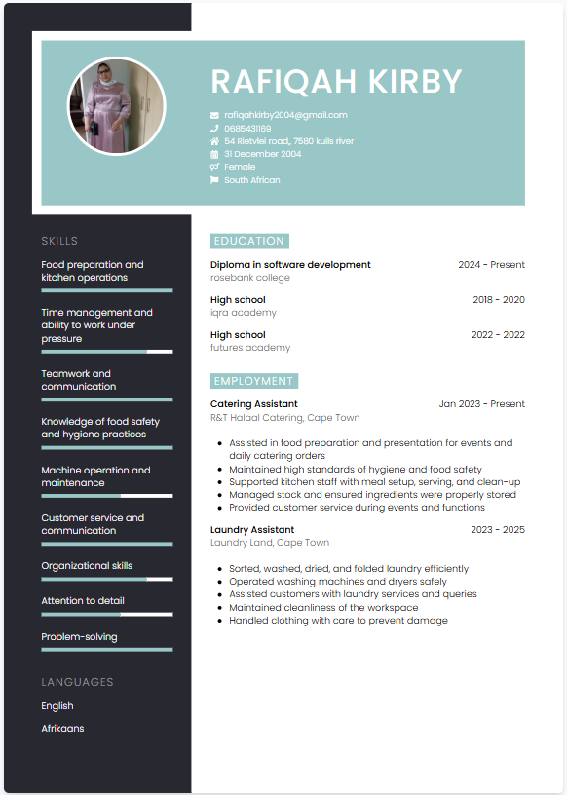

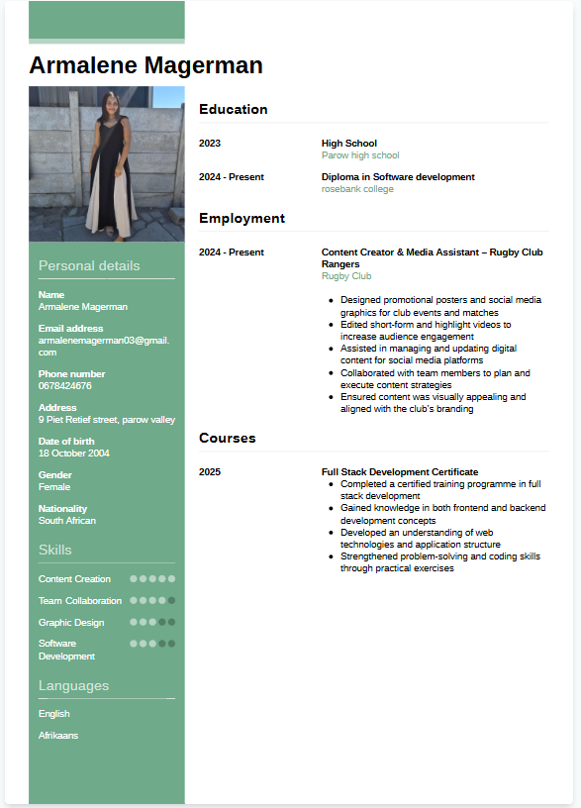

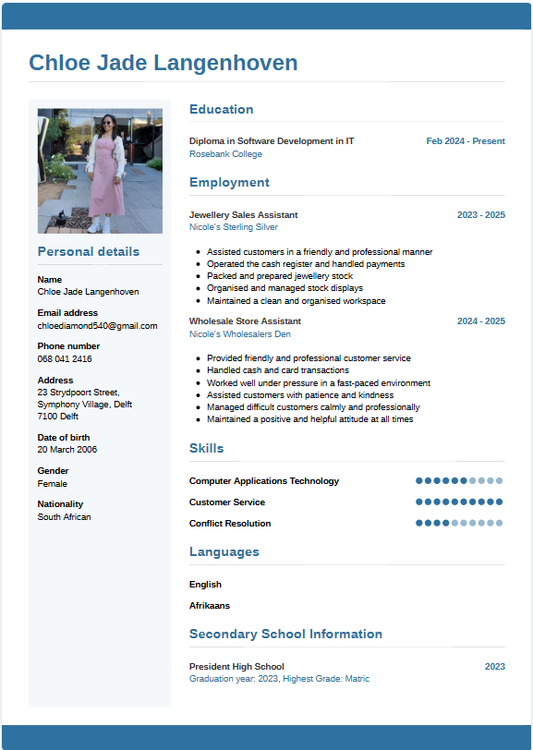

References

Elmasri, R. and Navathe, S.B. (2016) Fundamentals of Database Systems. 7th edn. Boston: Pearson.
Google (2026) Firebase Documentation. Available at: https://firebase.google.com/docs (Accessed: 20 April 2026).
Hoffer, J.A., George, J.F. and Valacich, J.S. (2016) Modern Systems Analysis and Design. 9th edn. Harlow: Pearson.
International Organization for Standardization (2018) ISO 31000: Risk management – Guidelines. Geneva: ISO.
Iziko Museums of South Africa (2026) Official website. Available at: https://www.iziko.org.za (Accessed: 20 April 2026).
Kendall, K.E. and Kendall, J.E. (2019) Systems Analysis and Design. 10th edn. Harlow: Pearson.
Kerzner, H. (2017) Project Management: A Systems Approach to Planning, Scheduling, and Controlling. 12th edn. Hoboken: Wiley.
Labour Guide (2026) National minimum wage increase effective 1 March 2026. Available at: https://labourguide.co.za/employment-condition/national-minimum-wage-increase-effective-1-march-2026 (Accessed: 20 April 2026).
Oracle (2026) MySQL Documentation. Available at: https://dev.mysql.com/doc/ (Accessed: 20 April 2026).
Pressman, R.S. and Maxim, B.R. (2019) Software Engineering: A Practitioner’s Approach. 9th edn. New York: McGraw-Hill.
Schwalbe, K. (2019) Information Technology Project Management. 9th edn. Boston: Cengage Learning.
Sommerville, I. (2016) Software Engineering. 10th edn. Boston: Pearson.

